

**Alamat Kantor**

Tambahin widget maps yang menuju lokasi

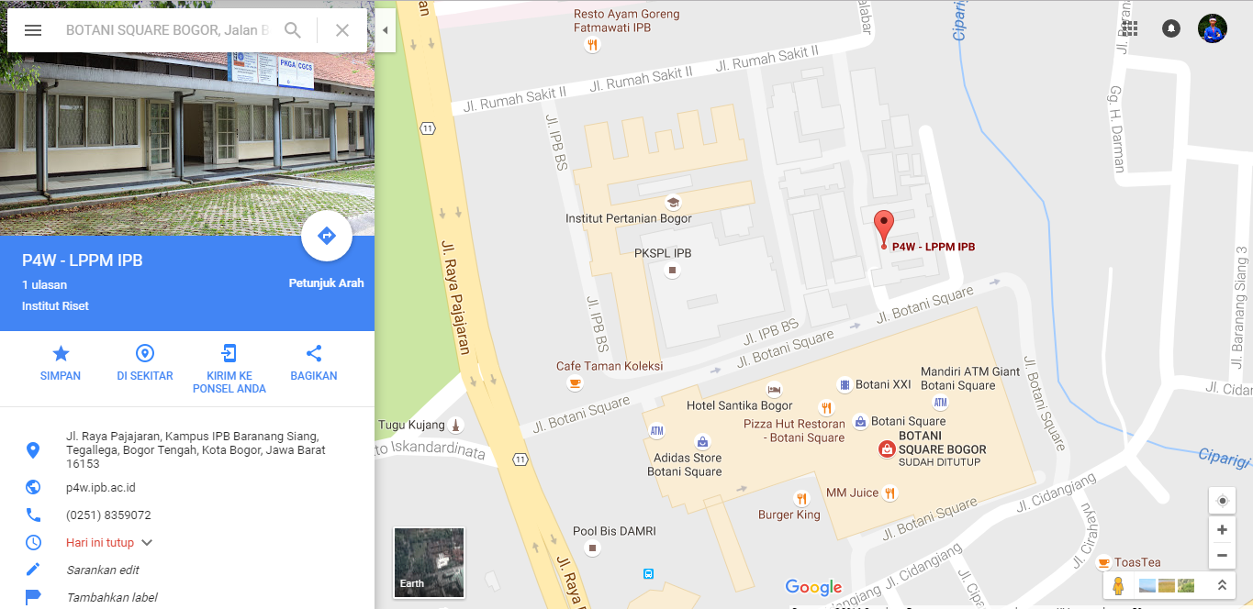

QuaRance - IncuBIE - LPPM IPB

(*Consulting & Training in Quality*)

Kampus IPB Baranangsiang , Jl. Pajajaran, Kota Bogor

e-mail: quarance@yahoo.com; quarance-ipb@ipb.ac.id

Fax. (0251) 8652046

Hotline service (SMS/WA): 081 298 63 130

~ *Think Quality Think QuaRance* ~

**Alamat Sekretariat Pendaftaran**

* 1. IncuBie-LPPM-IPB, Kampus IPB Baranangsiang Bogor (Ibu Ine: 081319255589)
  2. P2SDM-LPPM-IPB, Kampus IPB Baranangsiang Bogor (Ibu Tini: 082110066311)
  3. LPPM-IPB, Gd. Rektorat IPB, Kampus Darmaga Bogor (Bp. Ikhwanto: 085814378276)